Exclusion
Find users who have placed at least one order but have NEVER ordered a product related to “History”

SQL Query
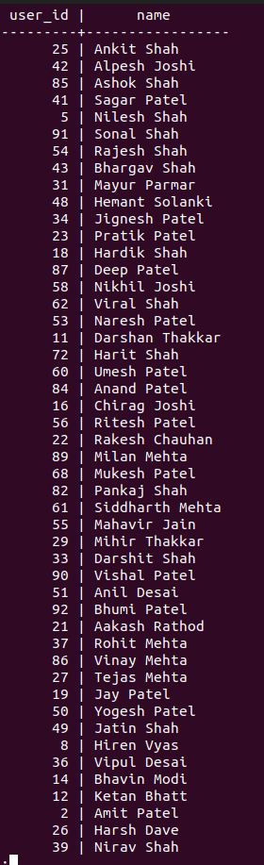
SELECT DISTINCT u.user_id, u.name FROM users u JOIN orders o ON u.user_id = o.user_id WHERE u.user_id NOT IN (SELECT o2.user_id FROM orders o2 JOIN order_items oi ON o2.order_id = oi.order_id JOIN products p ON oi.product_id = p.product_id WHERE p.product_name ILIKE '%History%');

Explanation
- This query selects users who have placed orders.
- The subquery finds users who ordered products whose name contains “History”.
- The NOT IN clause excludes those users, returning only users who never ordered History-related products.

2.Pattern Matching
Find products where the product name starts with “The” and ends with “S”

SQL Query
SELECT product_id, product_name FROM products WHERE product_name LIKE '%TV%';
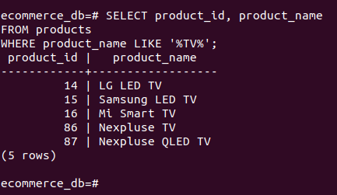

Explanation
- The LIKE operator performs pattern matching.
- The%S ensures the product name starts with “The”, ends with “S”, and allows any characters in between.

3.Range Filtering
Find orders placed between the years 2010 and 2026

SQL Query
SELECT order_id, user_id, order_date FROM orders WHERE order_date BETWEEN '2010-01-01' AND '2026-12-31';
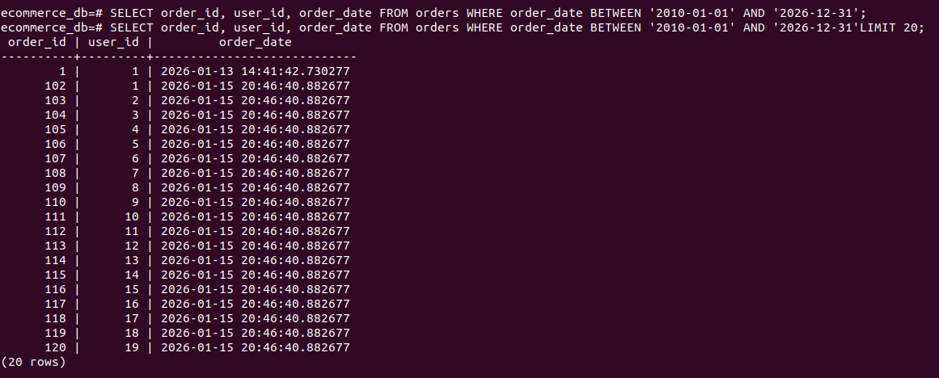

Explanation
- The BETWEEN operator filters records within a specific date range.
- This query retrieves all orders placed between 1990 and 2010, including both years.

